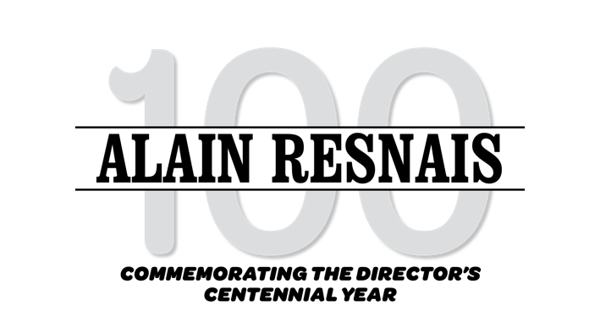

Friday, August 12 - Thursday, August 25

Friday, August 12

HIROSHIMA MON AMOUR
(1959, Alain Resnais)
DCP. Approx. 90 min.
12:30 & 5:10

MURIEL
(1963, Alain Resnais)
DCP. Approx. 115 min.
2:30 & 7:10

Saturday, August 13

MURIEL
(1963, Alain Resnais)
DCP. Approx. 115 min.
12:30 & 5:10

HIROSHIMA MON AMOUR
(1959, Alain Resnais)
DCP. Approx. 90 min.
3:00 & 7:40

Sunday, August 14

HIROSHIMA MON AMOUR
(1959, Alain Resnais)
DCP. Approx. 90 min.
12:30 & 8:40

LAST YEAR AT MARIENBAD
(1961, Alain Resnais)
DCP. Approx. 93 min.
2:30 & 6:35

JE T’AIME, JE T’AIME
(1968, Alain Resnais)
DCP. Approx. 91 min.
4:35

With support from the George Fasel Memorial Fund for Classic French Cinema, and Villa Albertine –
French Embassy in the US.

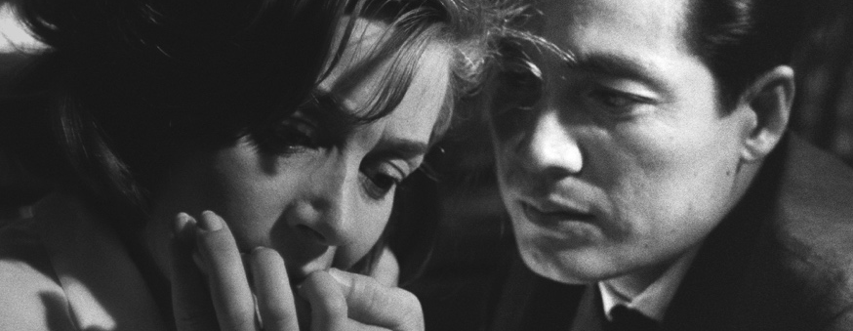

Monday, August 15

LAST YEAR AT MARIENBAD
(1961, Alain Resnais)
DCP. Approx. 93 min.
12:30

JE T’AIME, JE T’AIME
(1968, Alain Resnais)
DCP. Approx. 91 min.
2:35 & 8:15

HIROSHIMA MON AMOUR
(1959, Alain Resnais)
DCP. Approx. 90 min.
4:35

EARLY RESNAIS:
4 SHORT FILMS
Van Gogh (1948)
Guernica (1949)
Paul Gauguin (1949)
The Song of Styrene (1957)
All new DCP restorations. Approx. 70 min.
6:35

Tuesday, August 16

EARLY RESNAIS: 4 SHORT FILMS
Van Gogh (1948)
Guernica (1949)
Paul Gauguin (1949)
The Song of Styrene (1957)
All new DCP restorations. Approx. 70 min.
12:30

NIGHT AND FOG +
Toute la Mémoire du Monde
35mm. Approx. 32 min
DCP. Approx. 21 min
2:10 & 6:20

MURIEL
209 W Houston (W. 6th Ave.) 212-727-8110
(1963, Alain Resnais)
DCP. Approx. 115 min.
Buy Tickets Online: filmforum.org

3:40 & 7:50

HIROSHIMA MON AMOUR

Wednesday, August 17

STAVISKY
(1974, Alain Resnais)
DCP. Approx. 120 min.
12:30 & 5:30

MON ONCLE D’AMÉRIQUE
(1980, Alain Resnais)
35mm. Approx. 125 min.
3:00

PROVIDENCE
(1977, Alain Resnais)
DCP. Approx. 104 min.
8:00

Thursday, August 18

JE T’AIME, JE T’AIME
(1968, Alain Resnais)
DCP. Approx. 91 min.
12:30 & 9:00

HIROSHIMA MON AMOUR
(1959, Alain Resnais)
DCP. Approx. 90 min.
2:30

LAST YEAR AT MARIENBAD
(1961, Alain Resnais)
DCP. Approx. 93 min.
4:30

MON ONCLE D’AMÉRIQUE
(1980, Alain Resnais)
35mm. Approx. 125 min.
6:30

Friday, August 19

MÉLO
(1986, Alain Resnais)
DCP. Approx. 112 min.
12:30 & 7:20

LIFE IS A BED OF ROSES
(1983, Alain Resnais)
DCP. Approx. 110 min.
3:00

LOVE UNTO DEATH
(1984, Alain Resnais)
DCP. Approx. 92 min.
5:20

Saturday, August 20

LIFE IS A BED OF ROSES
(1983, Alain Resnais)
DCP. Approx. 110 min.
12:30

LOVE UNTO DEATH
(1984, Alain Resnais)
DCP. Approx. 92 min.
2:50

MÉLO
(1986, Alain Resnais)
DCP. Approx. 112 min.
4:50

STAVISKY
(1974, Alain Resnais)
DCP. Approx. 120 min.
7:30

Sunday, August 21

HIROSHIMA MON AMOUR
(1959, Alain Resnais)
DCP. Approx. 90 min.
12:30 & 6:40

STAVISKY
(1974, Alain Resnais)
DCP. Approx. 120 min.
2:30

LAST YEAR AT MARIENBAD
(1961, Alain Resnais)
DCP. Approx. 93 min.
4:35

JE T’AIME, JE T’AIME
(1968, Alain Resnais)
DCP. Approx. 91 min. 8:40

Monday, August 22

LIFE OF RILEY
(2014, Alain Resnais)
DCP. Approx. 110 min.
12:30

PRIVATE FEARS IN PUBLIC PLACES
(2006, Alain Resnais)
DCP. Approx. 120 min.
2:50 & 8:50

I WANT TO GO HOME
209 W Houston (W. 6th Ave.) 212-727-8110
(1989, Alain Resnais)
DCP. Approx. 100 min.
6:00*
*Followed by a conversation with singer/songwriter Amanda Green, daughter of star Adolph Green.

Tuesday, August 23
WILD GRASS
(2009, Alain Resnais)
35mm. Approx. 15 min
12:30 & 6:45

JE T’AIME, JE T’AIME
(1968, Alain Resnais)
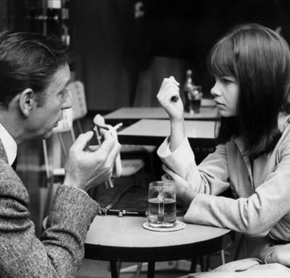
DCP. Approx. 91 min.

ALAIN RESNAIS’
LA GUERRE EST FINIE
(1966)
A new 4K Restoration will run from Friday, August 26 – Thursday, September 1

12:30, 3:00, 5:30, 8:00

A FILM DESK RELEASE

2:45

HIROSHIMA MON AMOUR
(1959, Alain Resnais)
DCP. Approx. 90 min.
4:45

LAST YEAR AT MARIENBAD
(1961, Alain Resnais)
DCP. Approx. 93 min.
9:00

Wednesday, August 24

MON ONCLE D’AMÉRIQUE
(1980, Alain Resnais)
35mm. Approx. 125 min.
12:30

MURIEL
(1963, Alain Resnais)
DCP. Approx. 115 min.
3:00 & 7:50

LIFE OF RILEY
(2014, Alain Resnais)
DCP. Approx. 110 min.
5:30

Thursday, August 25

HIROSHIMA MON AMOUR
(1959, Alain Resnais)
DCP. Approx. 90 min.
12:30 & 4:35 & 8:40

LAST YEAR AT MARIENBAD
(1961, Alain Resnais)
DCP. Approx. 93 min.
2:30 & 6:35

